# **Create a cluster**

Click Shared Cluster 🡪 Free cluster for a single account.

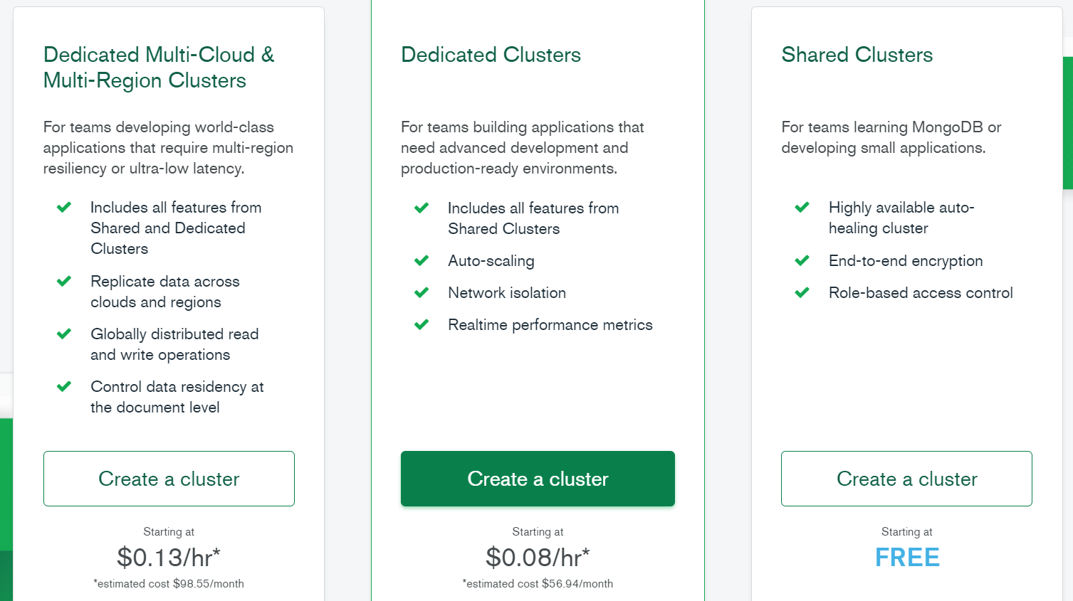

Select Mumbai as Cluster location

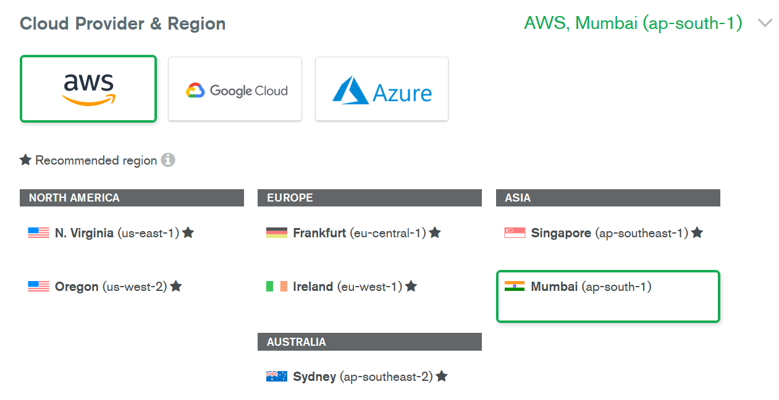

Free tier 🡪 SO No backup

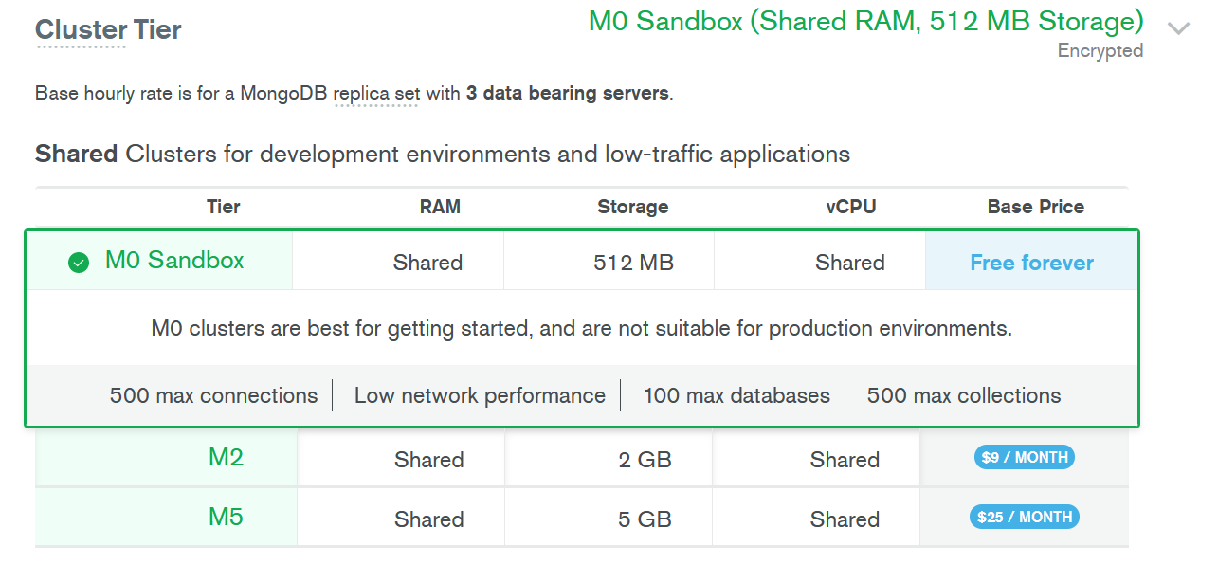

Change the cluster name  
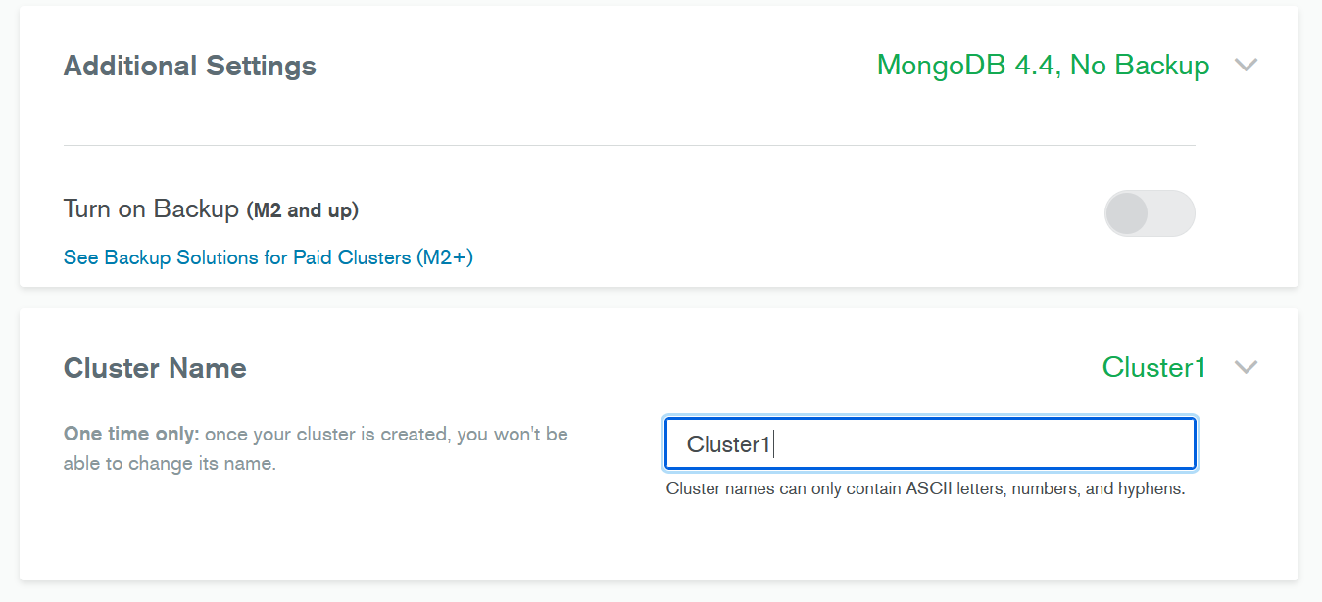

# **Create a data-base inside the cluster**

Click Add My Own Data

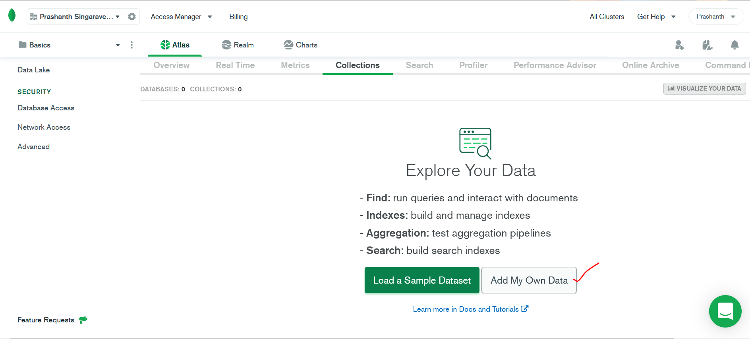

Create the data-base and collection(i.e tables)  
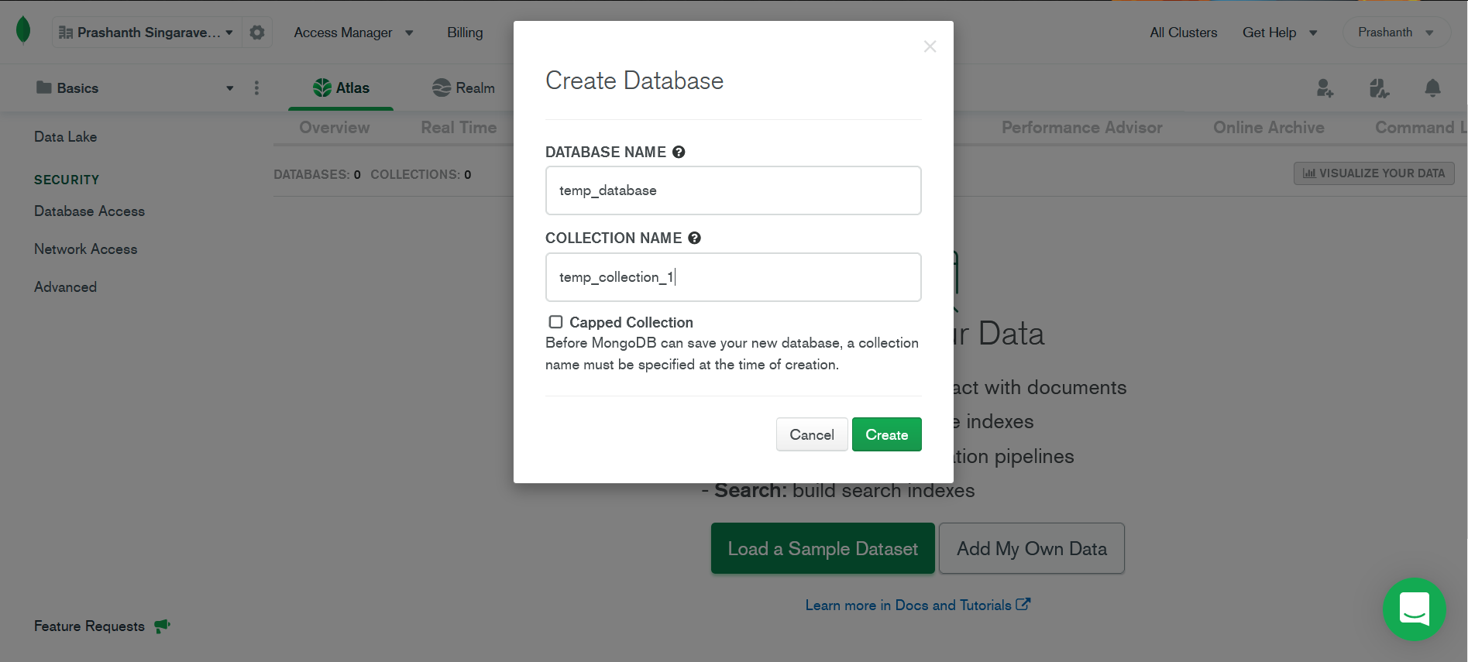

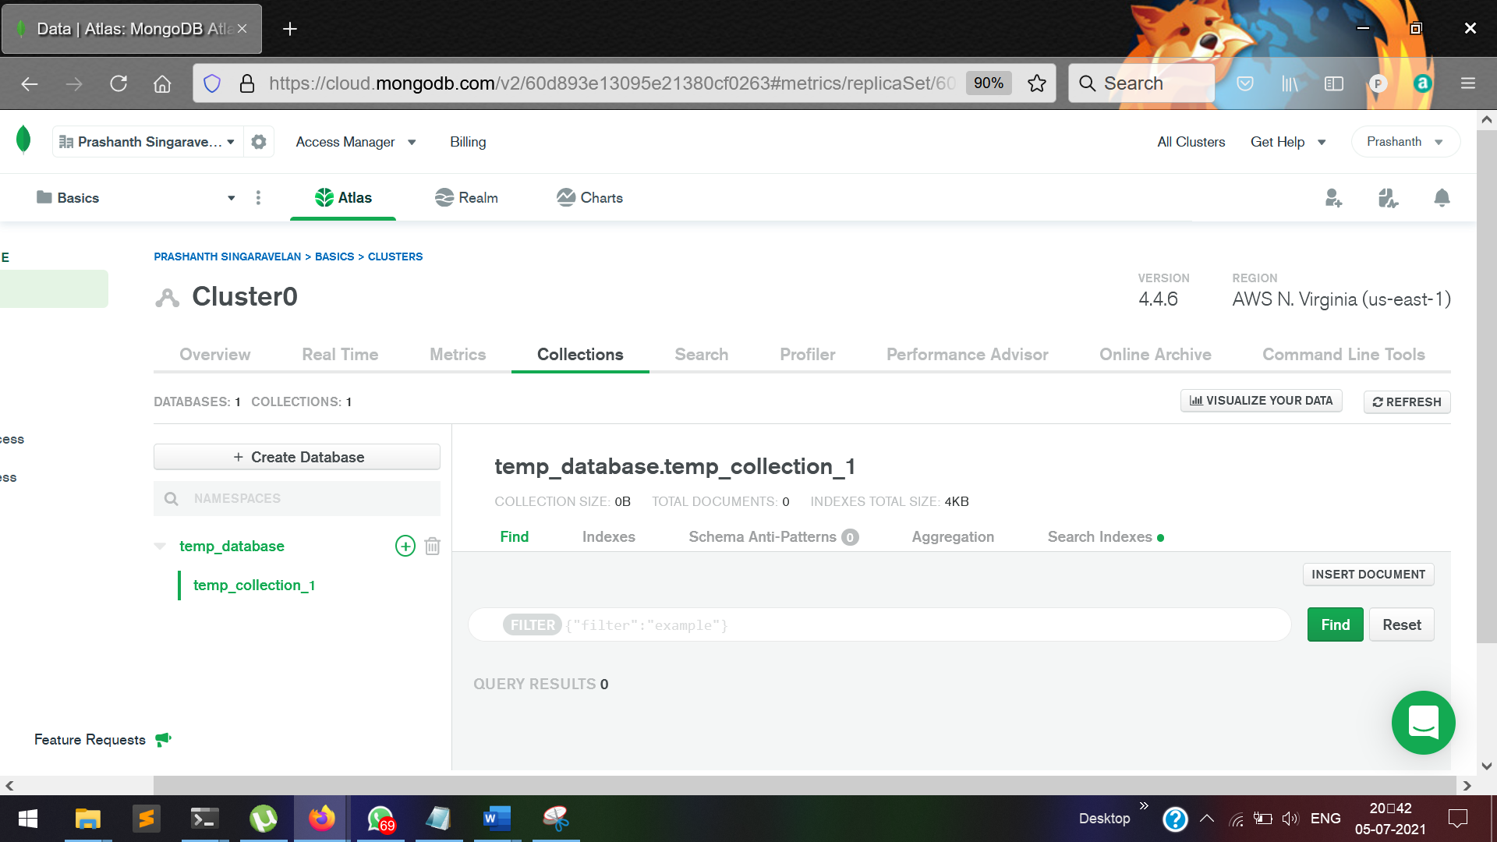

We can also add new collections to the data-base.

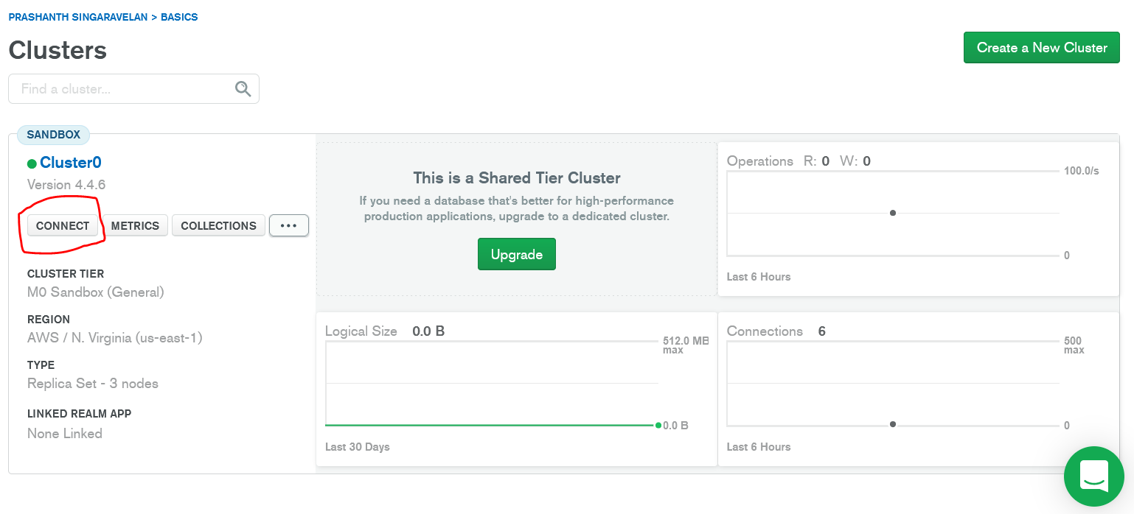

# **Connect to a cluster**

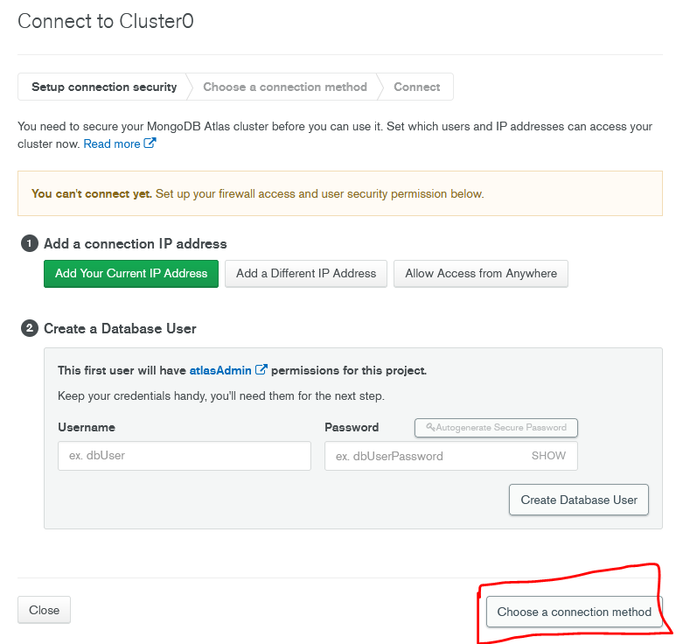

Important steps

Click Add your Current address IP.  
Create a data-base user.

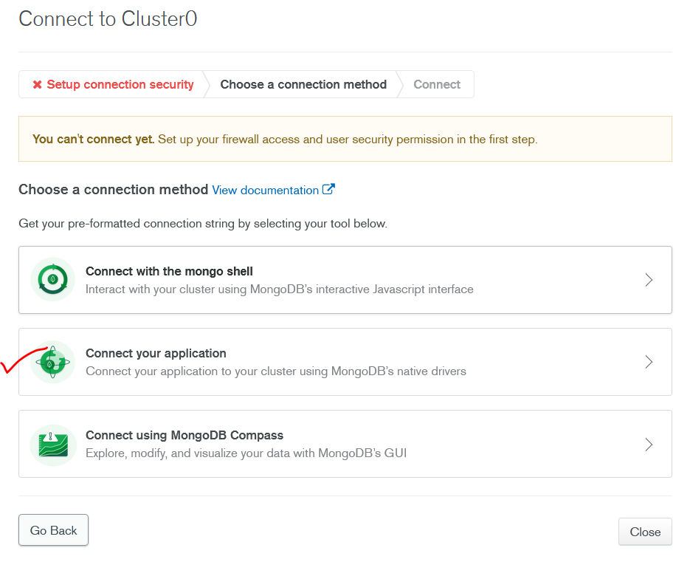

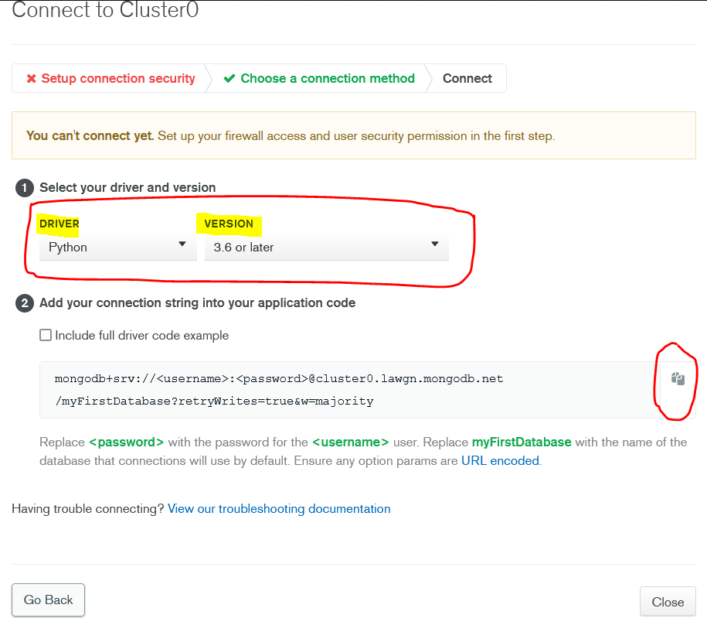

# **Copy the link in the code editor**

Give the user name and password in the link that we have copied.

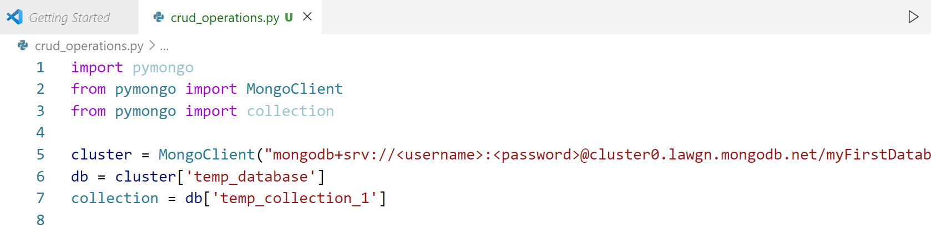

# **Install pymongo**

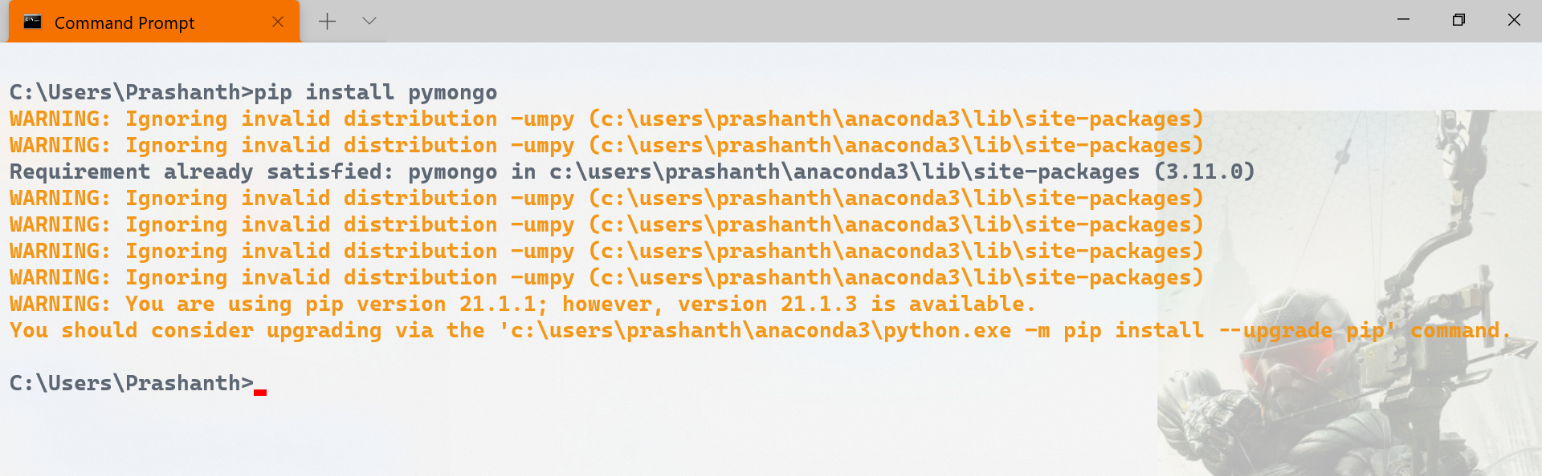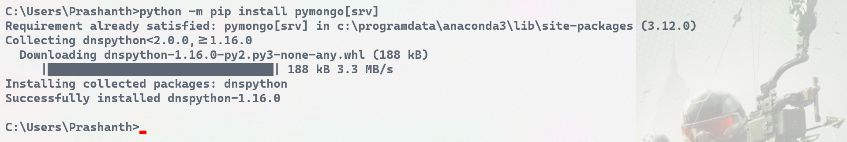  
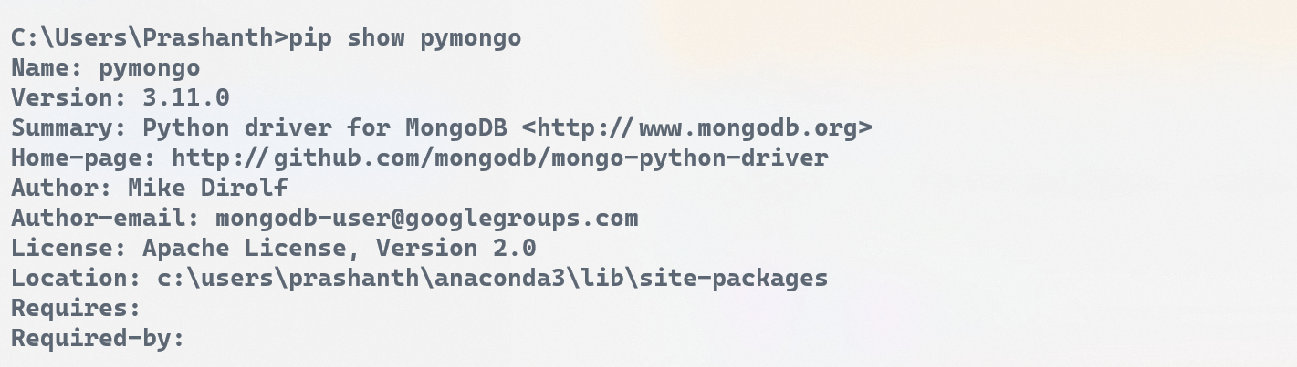

# **Connecting via mongo db shell**

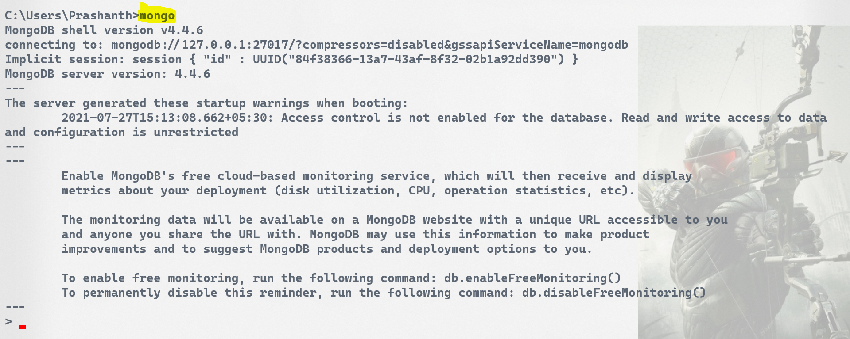

# **Connecting via mongo Compass**

